Stakeholder Update
June 2024

Hillsborough investigations’ outcome letters
In our May update, we referred to the Hillsborough investigations’ outcome letters, which will set out the details of a complaint or conduct investigation undertaken, an analysis of the evidence, and the opinions made by the IOPC Hillsborough decision maker Sarah Green.
We are now in a position to start sending these letters from the week commencing Monday 17 June 2024.
Our statutory obligations under the Police Reform Act (PRA) are to inform the relevant police force or police and crime commissioner (PCC) of the decision maker’s draft opinions and decisions, and to send them the corresponding complaint or conduct reports. Given the volume of complaint and conduct matters, we are sending these out to relevant police forces and PCCs in batches. This means that we will therefore receive responses back from them—if they choose to make them—over a period of time.
Once the decision maker has considered any representation a force or commissioner may wish to make, she will finalise her opinions and a letter will be sent to the complainant or, where relevant, Interested Person (IP). All former officers who are the subject of a complaint or conduct matter will also receive a letter with the finalised outcome.
The letters will be sent individually but will not be made publicly available at that point. As we have previously said, we intend to publish a large number of reports on the Hillsborough investigations’ website. Complainants have been personally notified if their complaint report will be published on the website.
As we will be sending almost 500 personalised outcome letters and managing the delivery and receipt to and from forces and commissioners, this process will take some months to complete. We will provide an update on the process before the end of the summer.
To find out more about our work or to request this document in an alternative format, you can contact us in a number of ways:
Independent Office for Police Conduct (IOPC)
Hillsborough PO Box 1245 Warrington WA1 9FW

Tel: 0161 246 8503
Email: hillsborough@policeconduct.gov.uk
Website: www.policeconduct.gov.uk

We welcome telephone calls in Welsh
Rydym yn croesawu galwadau ffôn yn y Gymraeg

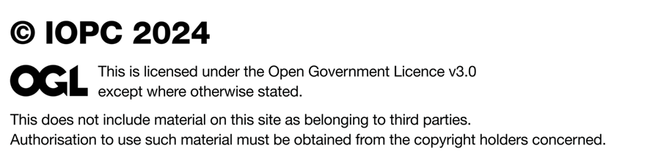
Published June 2024

